**Question1**

**A:** The code of this question is as following:

#include<iostream>

#include<stdlib.h>

#include<ctime>

using namespace std;

int partition(int A[],int p,int q)

{

int d,i,j,x;

x = A[p];

i = p;

for (j = p + 1; j <= q; j++)

{

d = 0;

if (A[j] <= x)

{

i++;

d = A[j];

A[j] = A[i];

A[i] = d;

}

}

d = A[i];

A[i] = A[p];

A[p] = d;

return i;

}

int randomized_partition(int A[], int p, int q)

{

int i,d,k;

i = (int)((double)rand()/RAND_MAX)%(q-p)+p;

d = A[i];

A[i] = A[p];

A[p] = d;

k = partition(A, p, q);

return k;

}

void randomized_quicksort(int A[], int p, int q)

{

int r;

if (p < q)

{

r = randomized_partition(A, p, q);

randomized_quicksort(A, p, r - 1);

randomized_quicksort(A, r + 1, q);

}

}

int main()

{

int A[101];

int i,d;

double n;

clock_t start, end;

for (i = 1; i <=100; i++)

{

A[i] = i ;

}

for(i=1;i<=5;i++)

{

start=clock();

randomized_quicksort(A, 1, 100);

end=clock();

n= (double)(end - start) / (double)(CLOCKS_PER_SEC)*1000;

cout<<"In the No."<<i<<" time, the randomized quicksort spends "<<n<<"ms running.";

cout<<endl;

}

}

And the result of the codes is shown as the picture below:

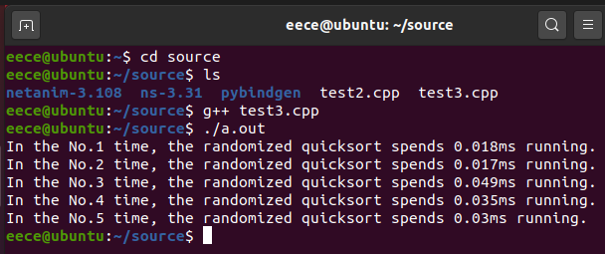

**Question 2**

**A:** Here is the codes of the question:

#include<iostream>

using namespace std;

void max_heapify(int A[], int i,int n)

{

int d, left, right;

int largest;

left = 2 * i;

right = 2 * i + 1;

if ((left<=n) && (A[left] > A[i]))

largest = left;

else

largest = i;

if ((right<=n)&&(A[right]>A[largest]))

largest = right;

if (largest != i)

{

d = A[i];

A[i] = A[largest];

A[largest] = d;

max_heapify(A, largest, n);

}

}

void build_max_heap(int A[],int n)

{

int i;

for (i = n / 2; i >= 1; i--)

{

max_heapify(A,i,n);

}

}

void print_vector(int v[], int n)

{

int i;

cout << "Vector:";

for (i = 1; i <=n; i++)

cout << " " << v[i];

cout << endl;

}

int main()

{

int A[101];

int i,d,n;

int largest;

for (i = 1; i <=100; i++)

A[i] = i;

print_vector(A, 100);

for (i = 1; i <=100; i++)

{

int num = rand() % 100+1;

d = A[i];

A[i] = A[num];

A[num] = d;

}

d = 0;

n = 100;

print_vector(A, 100);

build_max_heap(A, 100);

for (i = 100; i >= 2; i--)

{

d = A[1];

A[1] = A[i];

A[i] = d;

n--;

max_heapify(A, 1, n);

}

print_vector(A, 100);

}

The result of the codes is the picture below:

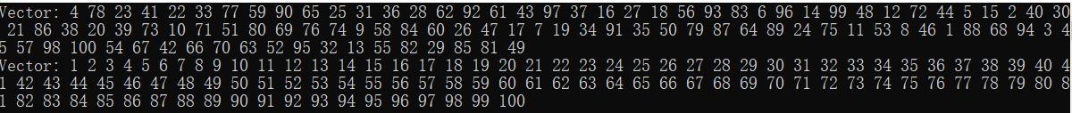

**Question3**

**A:** Here is the codes of the question:

#include<iostream>

using namespace std;

void print_vector(int v[], int n)

{

int i;

cout << "Vector:";

for (i = 0; i < n; i++)

cout << " " << v[i];

cout << endl;

}

int main()

{

int A[11] = {20,18,5,7,16,10,9,3,12,14,0 };

int B[11];

int C[21];

int i,j;

print_vector(A, 11);

for (i = 0; i < 21; i++)

C[i] = 0;

for (j = 0; j <11; j++)

C[A[j]] = C[A[j]] + 1;

for (i = 1; i <21; i++)

C[i] = C[i] + C[i - 1];

for (j = 10; j >=0; j--)

{

B[C[A[j]]-1] = A[j];

C[A[j]] = C[A[j]] -1;

}

print_vector(B, 11);

}

The result of the codes is shown in the picture below:

**Question4:**

**A:** Here is the codes of the question:

#include<iostream>

using namespace std;

void print_vector(int v[], int n)

{

int i;

cout << "Vector:";

for (i = 0; i < n; i++)

cout << " " << v[i];

cout << endl;

}

int main()

{

int A[7] = { 329,457,657,839,436,720,353 };

int B[7];

int C[10];

int i, j;

print_vector(A, 7);

for(i=0;i<10;i++)

C[i] = 0;

for (j = 0; j < 7; j++)

C[(A[j] % 10)] = C[(A[j] % 10)] + 1;

for (i = 1; i < 10; i++)

C[i] = C[i] + C[i - 1];

for (j = 6; j >= 0; j--)

{

B[C[(A[j] % 10)] - 1] = A[j];

C[(A[j] % 10)] = C[(A[j] % 10)] - 1;

}

for (j = 0; j < 7; j++)

{

A[j] = B[j];

}

for (i = 0; i < 10; i++)

C[i] = 0;

for (j = 0; j < 7; j++)

C[((A[j]/10)%10)] = C[((A[j] / 10) % 10)] + 1;

for (i = 1; i < 10; i++)

C[i] = C[i] + C[i - 1];

for (j = 6; j >= 0; j--)

{

B[C[((A[j] / 10) % 10)] - 1] = A[j];

C[((A[j] / 10) % 10)] = C[((A[j] / 10) % 10)] - 1;

}

for (j = 0; j < 7; j++)

{

A[j] = B[j];

}

for (i = 0; i < 10; i++)

C[i] = 0;

for (j = 0; j < 7; j++)

C[(A[j]/100)] = C[(A[j] / 100)] + 1;

for (i = 1; i < 10; i++)

C[i] = C[i] + C[i - 1];

for (j = 6; j >= 0; j--)

{

B[C[(A[j] / 100)] - 1] = A[j];

C[(A[j] / 100)] = C[(A[j] / 100)] - 1;

}

print_vector(B, 7);

}

The result of the codes is shown in the picture below:

